**Deploy Prometheus Stack Using Docker Compose**

Deploying Prometheus Stack using Docker Compose and Terraform involves

orchestrating the setup of Prometheus, Grafana, and any other necessary components

as Docker containers with Docker Compose.

**Infrastructure as Code using Terraform**

Create a Terraform template for creating [Ec2, Security group ] and also install

docker and docker-compose using userdata method.

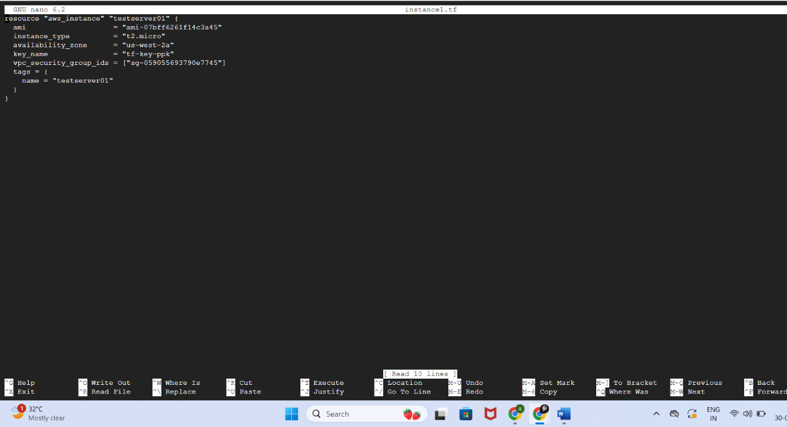

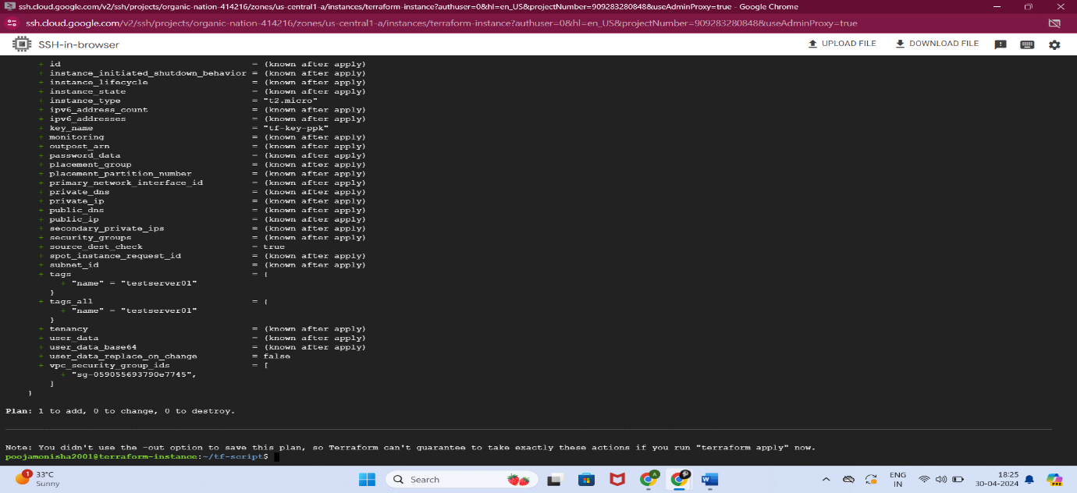

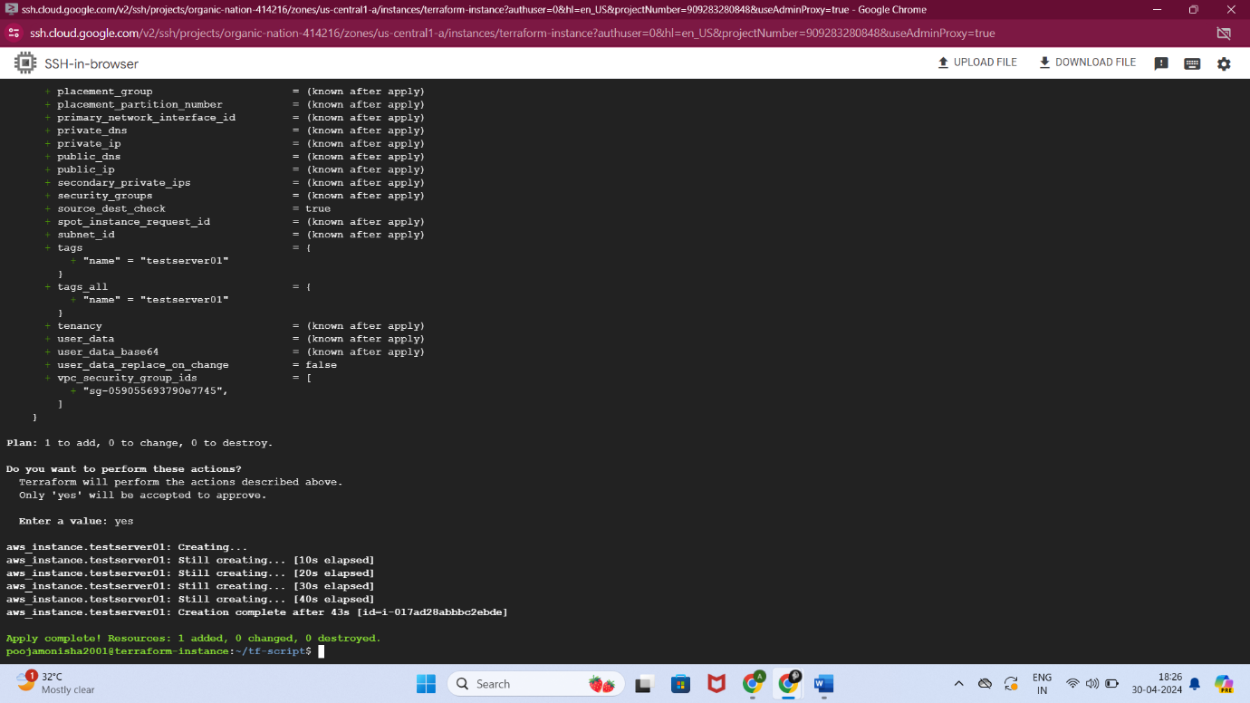

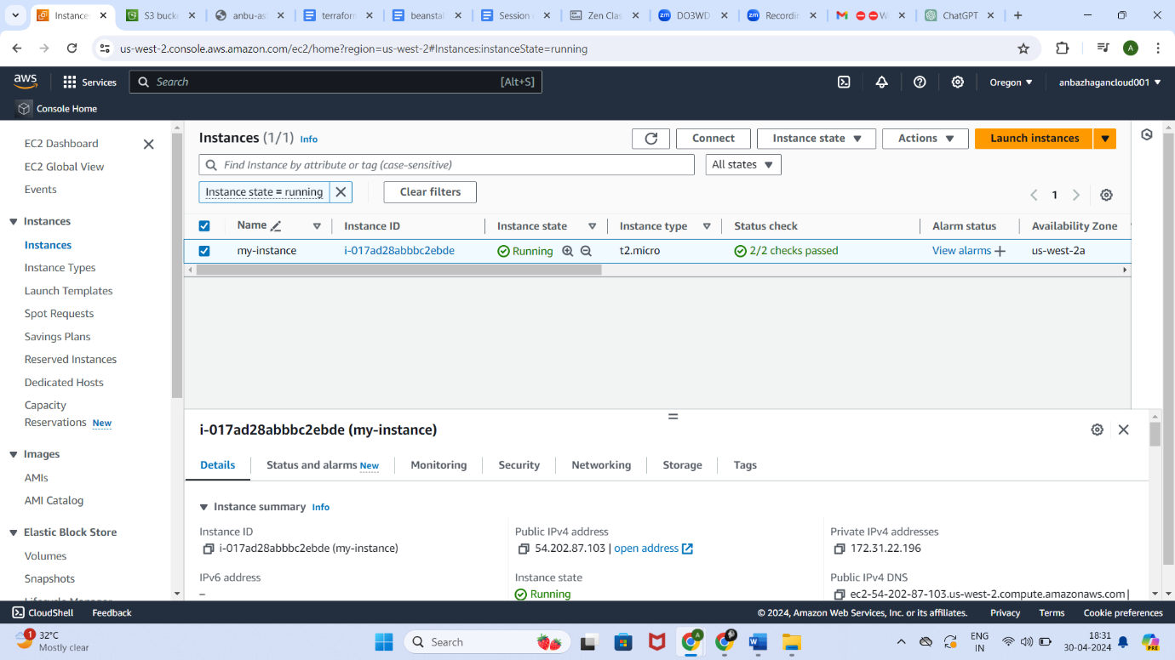

**2. Multi-Container Deployments using Docker Compose**

Template a docker-compose file for prometheus, Grafana and Node exporter.

Apply docker-compose file and create containers.

Docker-compose.yml

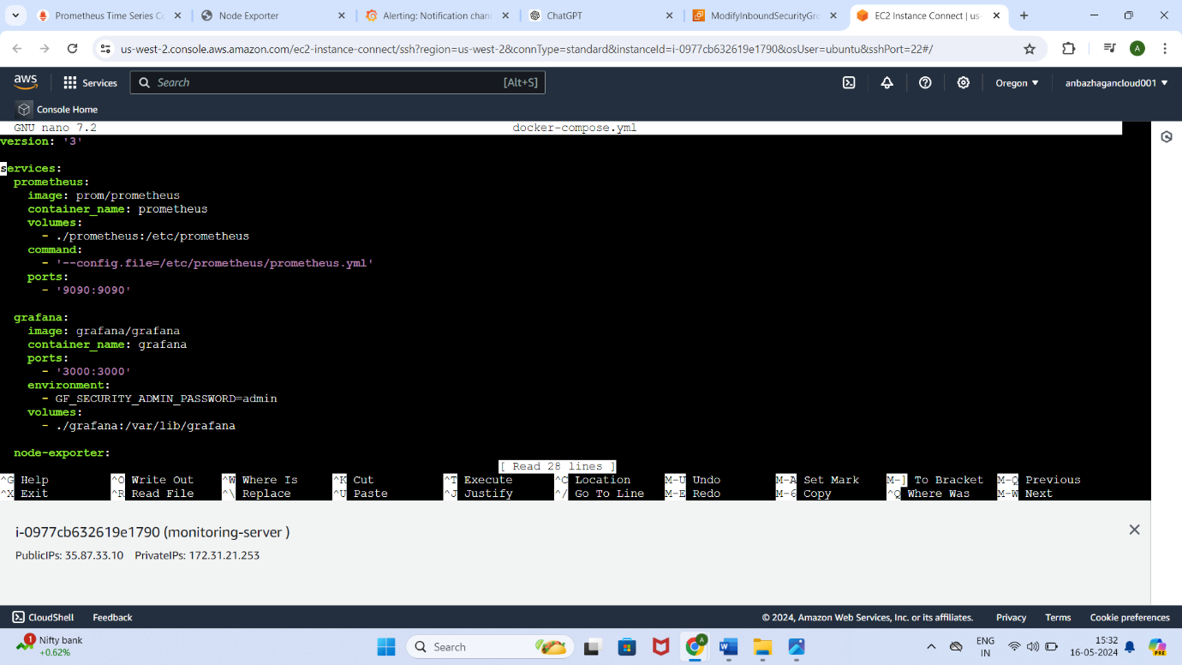

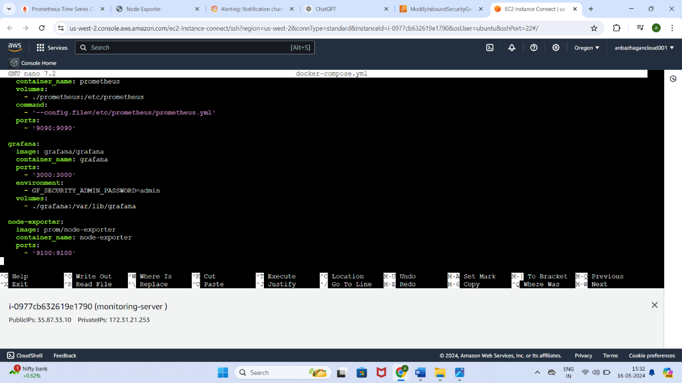

Prometheus.yml

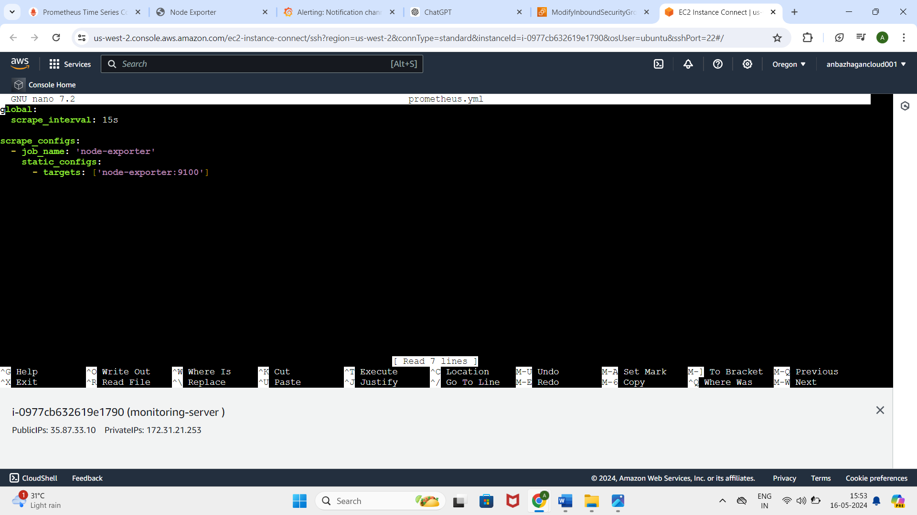

Docker-compose up -d command execution

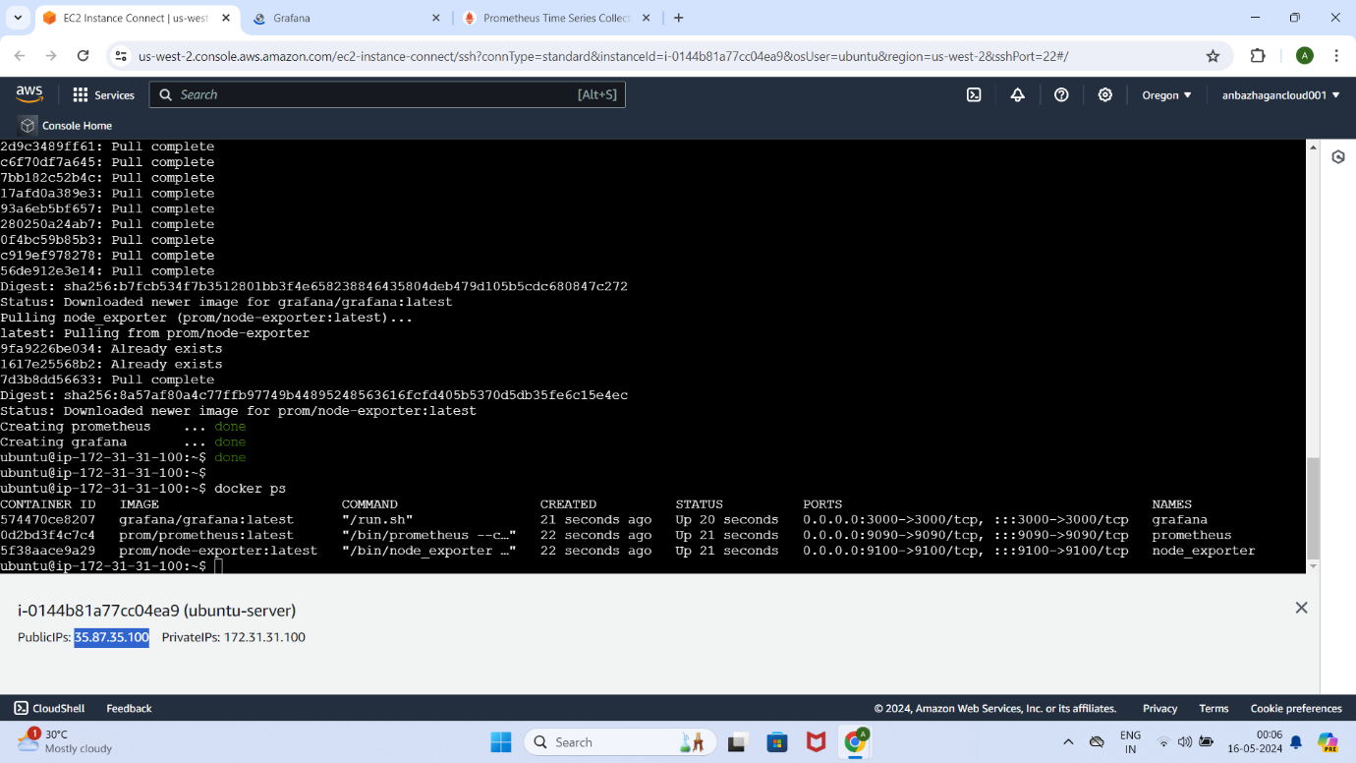

Prometheus server access with browser

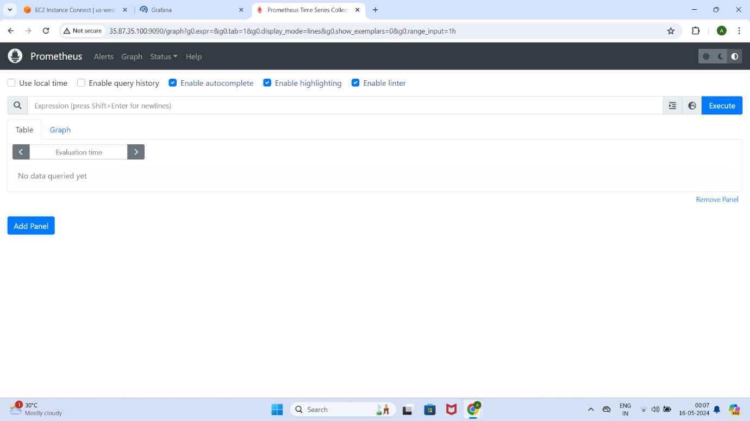

Garafana server access with browser

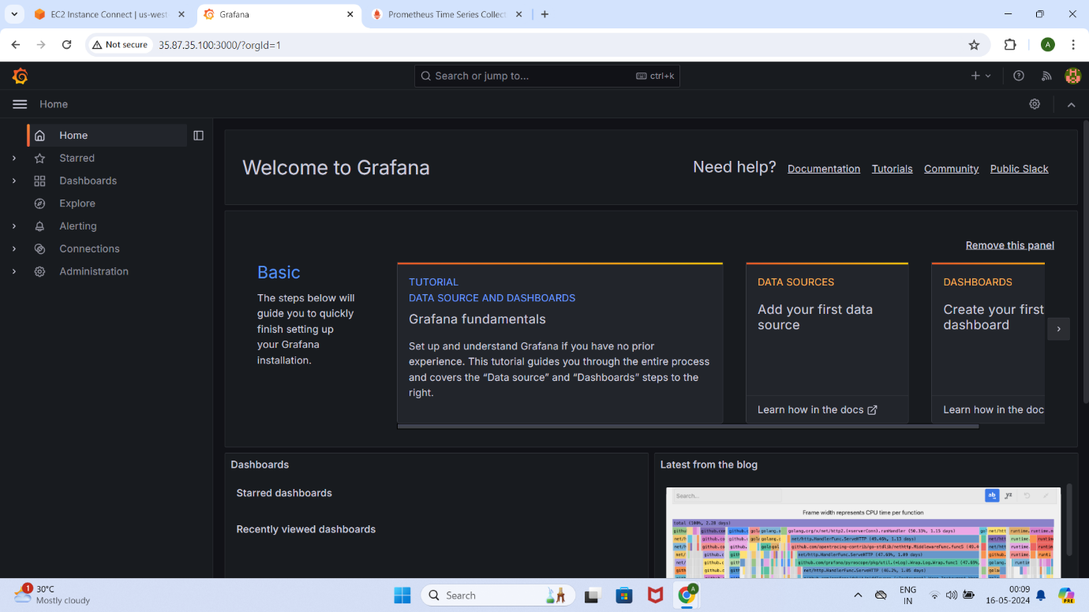

**Monitoring & Alerting using Prometheus Stack**

Configure Prometheus and Grafana containers and set alerts for high cpu usage and

send information using gmail.

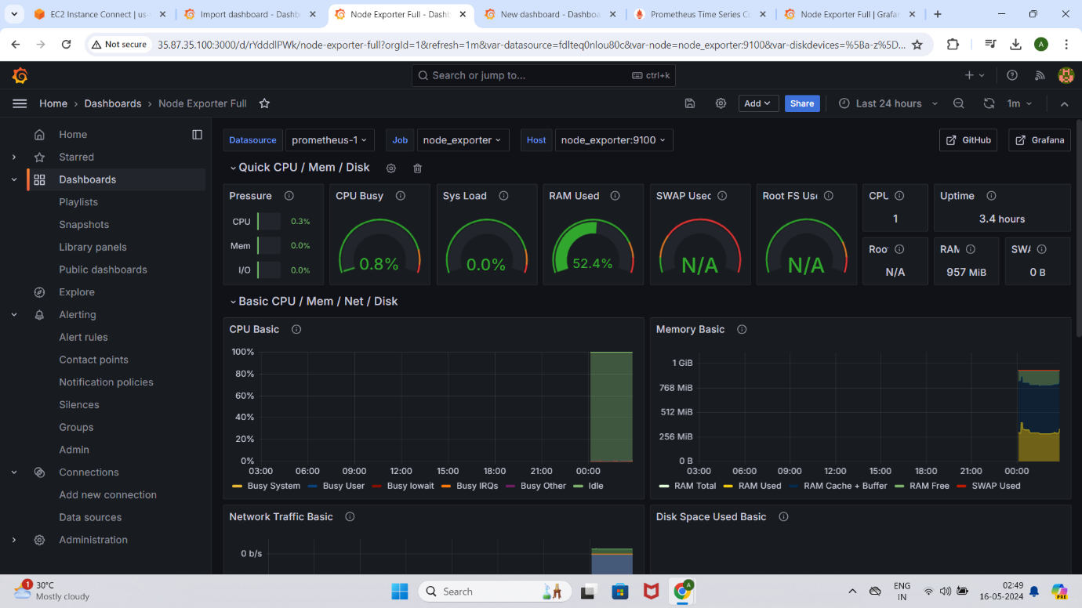

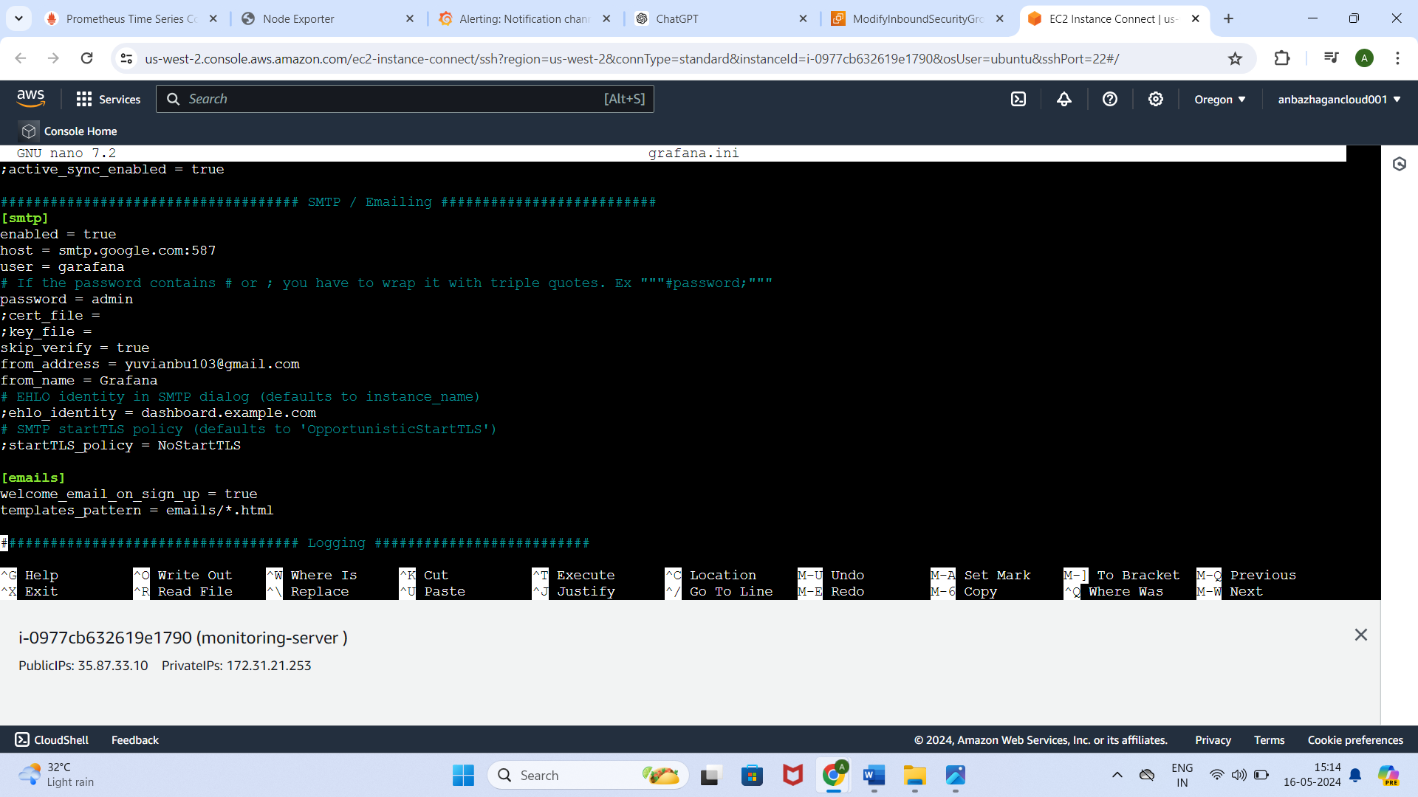

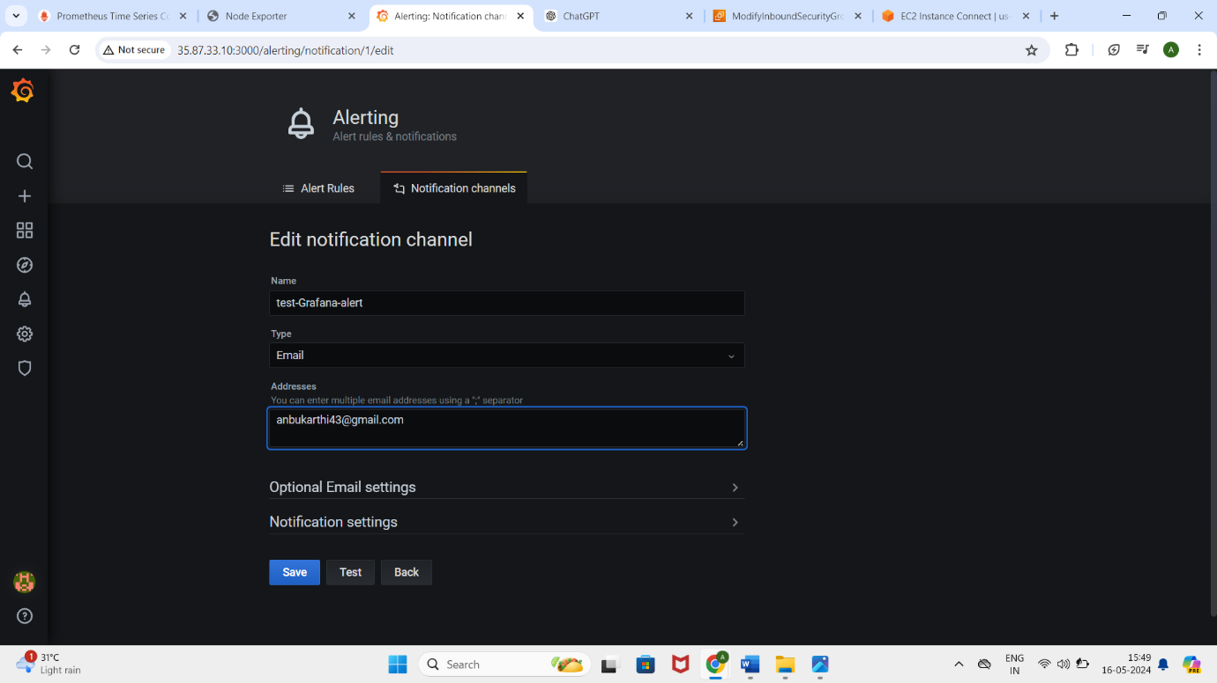

Configure Prometheus and Grafana containers and set alerts for high cpu usage monitoring activity done and send information using gmail is not receiving. last step send information through email is failed.